The present public demand for periodic revalidation of doctors is inevitable. The tradition of graduating from a training programme and obtaining a licence for life seems naïve in this era when the quality of care we provide is so dependent on our efforts to keep up to date.
Bashook PG, Parboosingh J Recertification and the maintenance of competence British Medical Journal 1998 316:545-8

What makes a good doctor?
- Clinical competence (knowledge, skills, audit of performance and for some keeping up to date with the clinical science that underpins their discipline)
- Clinical behaviour (making decisions, managing workload, attending to duties of care)
- Professional behaviour (Good communication skills, Respect for others, Works well with Colleagues, Good attitude to learning. Wants to improve quality of care)

What makes a bad doctor?

It is often easier to identify what we should be doing by looking at what we shouldn’t be doing! The relevant attributes, which are not exhaustive, for an unacceptable GP set out in Good Medical Practice for General Practitioners are:

- has little knowledge of developments in clinical practice
- has limited insight into the current state of his or her knowledge or performance
- selects educational opportunities which do not reflect his or her learning needs
- does not audit care in his or her practice, or does not feed the results back into practice
- is hostile to external audit or advice
- does not understand or respond to the law relating to general practice
- where employing staff, neither understands nor meets his or her responsibilities as an employer
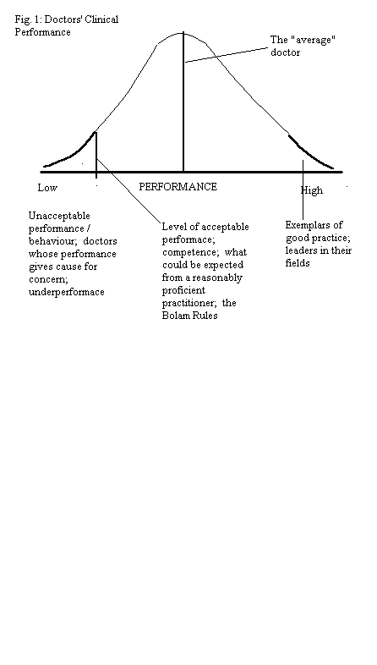
- has unsafe premises, e.g. hazardous chemicals or sharp instruments are inadequately protected
- Poloniecki, 1998: Pointed out the shocking fact that half of all doctors are below average!

The Appraisal & Revalidation System in the UK
- The amount of paperwork must be kept to a minimum and materials must be well presented and accessible
- Proper resources in terms of funding and protected time for doctors to carry out CPD should be a priority
- The system must be dynamic and flexible, ready to incorporate new approaches and differing methods of needs assessment

Re-validation is going to be more than demonstrating retention of existing skills: the whole New NHS is dedicated to more than quality control: it is about quality improvement. Re-validation will involve demonstrating that individuals are keeping up to date and engaging in effective continuing professional development to improve clinical performance.

Methods of Keeping Clinically Up to Date

- Courses, conferences, seminars
Beware of seminars and conferences that are passive. Good seminars and workshops should engage you and your brain. In that way, learning is internalised without too much effort.

Also be careful about the information you take from clinical ‘experts’ like hospital consultants at clinical meetings and conferences. In many instances the knowledge of specialists may not really be applicable to your patients and they don’t see the main types of patients you see because they don’t work in GP. Often, it may be more preferable to get say a GP with a Special Interest in Cardiology to talk about Heart Failure than a consultant. An ordinary GP might be even better, because they will start from your starting point and know your learning gaps and will then be able to seek to fill those gaps by finding out from others and then presenting back to you.

- Practice meetings, Discussion with Peers, Journal clubs, In-house practice based teaching
Often more relevant to your needs. Being more ‘close-knit’ than large conferences means it encourages more dialogue between participants which is better for learning as more relevant and pragmatic discussions ensue.

- Mentoring Schemes
This is a good way of getting some direction for your Postgraduate Education or GP Appraisal Lead. Usually a group of local GPs who have developed a scheme, the objectives of which are:
  - To encourage us to reflect on our own work
  - To enable us to identify areas of learning need
  - To help to address those needs
  - To enable us to feel good about what we do
  - To act as a resource for personal as well as professional development
  - To help, and learn from, other such groups
  - To have influence over the development of primary care

- Private study: books, journals, CD ROMS, Web-based material.
To be worthwhile, this needs to be more than browsing the reviews and the obituaries. Better done when it is problem-based rather than just general reading i.e. reading needs to be directed and focussed on answering specific clinical questions.

Books – why use books when there’s so much on the net that is reliable? Things like NICE’s CKS? GP Notebook? There are others that are great for teaching – for example Symptom Sorter, CSA symptom sorter, Guidelines by Medendium. When you teach, you also learn. Beware of books that don’t have new editions.

- Medical Journals
Beware of individually presented research papers. How does it sit with other research examining the same subject matter? Has the research paper been biased in anyway? What are the limitations of that research paper? Many of us are not good at critically evaluating research papers – after all, we are busy GPs. So, it’s often best to stick to reviews of research relating to a clinical area (i.e. clinical reviews) done by those who do this day in and out (i.e. is their bread and butter) – like the DTB (Drugs & Therapeutics Bulletin) or NICE guidelines. InnovAIT, BJGP, BMJ are good medical journals which publish clinical reviews and are independent.

Be careful…some journals are not independent. Often called ‘throwaways’ they are usually glossy and often present information in an easily digestible format. They can be characterized as: free of charge, carrying more advertisements than text, not published by professional bodies, not publishing original work, variably subject to peer review, and deficient in critical editorials and correspondence. are promoted to the physician as a 'way to save time'. This applies to some journal supplements too. They sometimes report on commercially sponsored conferences; in fact, the whole supplement may be sponsored. So, don't assume that because a review article or research study appears in print that it is necessarily good science. Thousands of 'medical' journals are published and they vary enormously in quality. Only a relatively small proportion publish scientifically validated, peer reviewed articles. If in doubt about the scientific value of a journal, verify its sponsors, consult senior colleagues, and check whether it is included in the Index Medicus, which covers all major reputable journals.

Pharmaceutical Industries as a source of Information (Drug Reps)
Many GPs who see drugs reps say that they find them useful because they can provide an overview of a clinical area and its management. Drug reps will often go through things like – first and second level treatments and so on.

However, although they may provide good treatment algorithms, the research says that their products will bias you no matter how good you think you are at retaining a sense of self-control. If you think “I don’t mind seeing them, and I will take what they say with a pinch of salt, but I’ll just pretend that I’m interested and keep nodding” – then guess what, YOU WILL have a tendency towards prescribing their drug – that’s what the research shows.

Also bear in mind that drugs reps are going to be biased. They are sales people at the end of the day. Their job is to ‘sell it to you’. So, it is likely they will present data to you in a way that is biased. They are more likely to present papers that support their drugs than better papers that might support their rivals!

And when you’re seeing reps, you will think you are updating your clinical knowledge in a way that means that you will less likely to attend more neutral teaching and learning places like workshops and courses.

In my practice, I stopped seeing reps years ago. The result? I have more time to do my clinical and non-clinical tasks. I don’t have to listen to boring blurbs of information. And I go to more interesting clinical events instead where I interact with colleagues from neighbouring practices. And it’s a pleasure doing that because sometimes I just meet them for a coffee and chat.

